SUMMER INTERNSHIP

ENTITLED

**“AUTOMOBILE** **TRACTOR ASSEMBLY”**

SUBMITTED IN PARTIAL FULFILLMENT OF THE REQUIREMENTS

FOR THE AWARD OF THE DEGREE OF

**BACHELOR OF ENGINEERING**

**IN**

**MECHANICAL ENGINEERING**

BY

1. **TANK SAGARKUMAR BHARATBHAI (200150119530)**

UNDER THE GUIDANCE OF

**Prof. DER KAMLESH RAYSINGBHAI**

**INTERNAL-GUIDE**

**Mechanical Engineering Department**



**MECHANICAL ENGINEERING DEPARTMENT**

**GOVERNMENT ENGINEERING COLLEGE,**

**BHUJ (INDIA) -370001**

**2022-23**

**CERTIFICATE**

This is to certify that the Internship entitled **"AUTOMOBILE TRACTOR ASSEMBLY"** submitted by **Tank Sagarkumar Bharatbhai (200150119530)** in partial fulfilment of the requirements for the award of degree of **"Bachelor of Engineering”** in **Mechanical Engineering** during the academic year 2022-23 **(7th Semester)**, at the **Government Engineering College, Bhuj** is the record of his own work carried out under our supervision and guidance and the matter embodied in this report has not been submitted to any other University or Institution for award of any degree or diploma.

**Prof. der kamlesh R. Prof. Pravin Rathod.**

**Internal Guide Head of Department**



**Mechanical Engineering Department**

**Government Engineering College,**

**Bhuj (India) -370001**

**SUMMER INTERNSHIPAPPROVAL CERTIFICATE**

This is to certify that the Internship entitled **“Automobile Tractor Assembly"** submitted by **Tank Sagarkumar Bharatbhai (200150119530)** in partial fulfillment of the requirements for the award of the degree of **"Bachelor of Engineering”** in **Mechanical Engineering** during the academic year 2022-23 **(7th Semester)**, at the **Government Engineering College, Bhuj** is hereby approved

**Examiners:**

**1.**

**External**

**2.**

**Internal**

**Date:**

**Place: Government Engineering College, Bhuj**

|  |
| --- |
|  |
| ***Table of Contents*** |

|  |  |
| --- | --- |
| **Acknowledgements** | i |
| **Abstract** | ii |
| **List of Tables** | iii |
| **List of Figures** | iv |
| **Nomenclature** | v |
| **Chapter 1 : Introduction** | 1 - 2 |
| * 1. Introduction | 1 |
| * 1. Product overview | 2 |
| **Chapter 2 : Literature Review** | 3 |
| 2.1 Literature Review | 3 |
| **Chapter 3 : Cleaning Process** | 4 - 5 |
| 3.1 Cleaning Machine-1 | 4 |
| 3.2 Cleaning Machine-2 | 5 |
| **Chapter 4 : Engine Assembly & Testing** | 6 - 11 |
| 4.1 Engine Assembly | 6 |
| 4.1.1 Crank case loading and bracket mounting. | 6 |
| 4.1.2 Cam follower sub assembly & mounting. | 7 |
| 4.1.3 Fly Wheel Bush Filament. | 7 |
| 4.1.4 Piston & Oil Sump Mounting. | 8 |
| 4.1.5 Timing gear train & back lash check. | 9 |
| 4.1.6 Cylinder head assembly. | 9 |
| 4.1.7 Intake & Exhaust mounting fuel filter mounting. | 10 |
| 4.1.8 PTO mounting. | 10 |
| 4.1.9 Alternator mounting | 10 |
| 4.2 Engine Testing | 11 |
| **Chapter 5 : Transmission system assembly** | 12 - 16 |
| 5.1 Spline shaft sub assembly mounting. | 12 |
| 5.2 Reverse idler gear assembly. | 13 |
| 5.3 Rail and Fork Assembly. | 13 |
| 5.4 Lay shaft assembly. | 13 |
| 5.5 BACKLASH (Differential). |  |
| 5.6 RAC sub assembly mounting. |  |
| 5.7 Brake assembly mounting. |  |
| 5.8 PTO shaft mounting. |  |
| 5.9 Transmission leakage testing. |  |
| **Chapter 6 : VTU** |  |
| 6.1 VTU Assembly |  |
| 6.1.1VTU Body |  |
| 6.1.2 VTU Control Valve1 |  |
| 6.1.3 VTU Testing and setting |  |
| **Chapter 7 : Paint Shop** |  |
| **Chapter 8 : Conclusion** |  |

**ACKNOWLEDGEMENT**

First and foremost I offer my sincerest gratitude to my guide Prof. Der kamlesh Raysinghbhai studies in Bachelor of engineering in mechanical engineering, government engineering college-bhuj & Panchnath Auto pvt.ltd.who has supported me throughout my industrial training with his patience and knowledge whilst allowing me the room to work in my own way. I attribute the level of my degree to his encouragement and effort and without him this report & industrial training, would not have been completed or written.

My heartiest thanks to Prof (Dr). Pravin Rathod , Head of the Department of Mechanical Engineering. Government engineering college-bhuj, who has always shown kind concern and consideration regarding my academic requirements, I wish to express my deep gratitude to------ for providing me with all the facilities and opportunities to complete this industrial training.

I would like to thank the management and employees of PANCHNATH AUTO PVT.LTD.for providing me the practical guidance and adequate support as and when required.

My sincere most thanks to the administration and management of. Government Engineering college-Bhuj, for their untiring effort in encouraging me to pursue academic growth.

I am indebted to all the staff, colleagues and friends who have directly or indirectly helped me towards the achievement of this task

Last but not the least, God is great.

**ABSTRACT**

Industrial training is a part of the 7 semester. In this training we get practical knowledge about real work and problem of the industrial product. In this training, we learn about row material, the process of the manufacturing of the part, testing of the product and delivery of the product. We get experience about the industrial work. In daily life, all the companies are tried to improve performance and their reputation. All the workers are work with together. We work in practical view. I manage the relation between workers and supervisor. I try to give best to the company. I tried helpful to the company. I also thankful to our faculty members to teach theoretical knowledge in Mechanical branch to improve my practical knowledge in industries. I also thankful the PANCHNATH AUTO PVT.LTD. Company. It grand the permission to give me training.

|  |  |  |
| --- | --- | --- |
|  |  | |
|  |  | |
| Table 3.1: Cleaning Machine | | 28 | |
| Table 4.1: Engine | | 31 | |
| Table 5.1: Transmission | | 37 | |
| Table 6.1: Hydraulic lift | | 40 | |

|  |
| --- |
|  |
| ***List of Tables*** |

|  |  |
| --- | --- |
| Figure 1.1 Yuvraj215-Tractor | 17 |
| Figure 4.1 Crank case loading and breaking mounting. | 21 |
| Figure4.2 Cam follower sub assembly | 22 |
| Figure 4.3 Piston & oil sump mounting | 23 |
| Figure 4.4 Cylinder head assembly | 23 |
| Figure 4.5 Push road tube and rock arm cover | 30 |
| Figure 4.6 Alternator mounting | 34 |
| Figure 4.7 Engine testing | 35 |
| Figure 5.1 Trans case assembly | 38 |
| Figure 5.2 Spline shaft assembly | 40 |
| Figure 5.3 SHIM gear | 42 |
| Figure 5.4 Rail and fork assembly | 43 |
| Figure 5.5 Lay shaft assembly | 46 |
| Figure 5.6 Differential | 48 |
| Figure 5.7 RAC sub assembly | 49 |
| Figure 5.8 Break assembly | 50 |
| Figure 5.9 PTO shaft mounting | 52 |
| Figure 6.1 VTU body |  |
| Figure 7.1 Different tanks |  |
| Figure 7.2 Water-dry-oven |  |
| Figure 7.3 Tractor body part |  |

|  |
| --- |
|  |
| ***List of Figures*** |

**NOMENCLATURE**

**Nomenclature of Yuvraj215 Tractor**

* **Nomenclature of engine**

1. HP -- horsepower
2. CC -- Clubic centimeter
3. RPM -- revolutions per minute

* **Nomenclature of transmission**

1. Kmph -- kilometer per hours
2. μm -- micrometer
3. RAC-- real axle coller
4. PTO -- power take off
5. mbar -- millibar

* **Nomenclature of vtu**

1. VTU -- hydraulic lift

* **Nomenclature of paint Shope**

1. Material Grade covers the chemical -- Fc436
2. `C -- Temperature unit

**CHAPTER 1: INTRODUCTION**

* 1. **Company profile**

About Mahindra

Mumbai, August 1, 2012: Mahindra & Mahindra's Farm Equipment Sector (FES), a part of the U.S. $15.4 billion Mahindra Group, Maintained its leadership position in the tractor industry in July 2012.

Domestic sales in July 2012 stood at 15495 units during July 2011. Total Tractor sales (domestic + export) in July 2012 stood at 16521 units, as against 16692 units for the same period last year. Exports for the month of July 2012 stood at 1026 Units, as against 993 units in July 2011.

About The Mahindra Group

The Mahindra Group focuses on enabling people to rise. Mahindra operates in the key industries that drive economic growth, enjoying a leadership position in tractor, Utility vehicles, and information technology and vacation ownership. Mahindra has a presence in the automotive industry, agribusiness, aerospace, logistic, real estate, retail, steel and two wheelers.

A US $15.4 billion multinational group based in Mumbai, India, Mahindra employs more than 144000 people in over 100 countries. In 2011, Mahindra featured on the Forbes Global 2000 list, a listing of the biggest and most powerful listed companies in the world. Dun & Bradstreet also ranked Mahindra at No. 1 in the automobile sector in its list of India's Top 500 Companies. In 2010, majority stake in Korea's SsangYong Motor Company. www.mahindra.com

For Further enquiries

Rom Balwan

* 1. **PRODUCT OVERVIEW**

The Yuvraj 215's low cost of ownership and best-in-class fuel efficiency is bringing mechanization opportunities to farmers with small landholdings across India and revolutionizing earnings capabilities.

Yuvraj 215 designed for small farm operations. With one cylinder and 15 HP, the Yuvraj 215 is compact and easy to operate. We built it for long life and low maintenance, durability and dependability. It offers the first water-cooled single cylinder engine in the 15 HP segment, and its side shift gear is easy and comfortable to use.

The Yuvraj 215 achieves a top speed of 25 kmph, the highest in its class. It can haul up to 1.5 tons. It's ideal for farmers ready to upgrade from bullocks or power tillers, or for farmers who need an additional machine for specific applications like inter-culture, power generation, or water pumping. Farmers who cultivate vegetables, tend orchards, or raise cash crops can all benefit from the Yuvraj 215's strong value proposition of affordability, power, and performance. Yuvraj is used popularly in Cultivator, Rotavator, Boom spray, Blow sprayer, water pump, Trolley, Special attachment for Garbage handling across the state. Yuvraj enables the small farmer to own a tractor and benefit from mechanization, thus helping him boost his productivity.

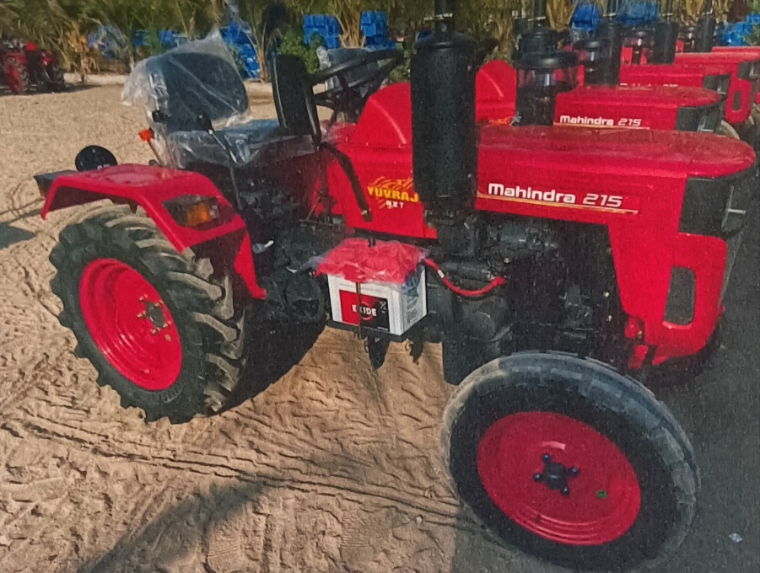

*Fig1.1*

**CHAPTER 2: LITERATURE REVIEW**

|  |  |  |  |  |
| --- | --- | --- | --- | --- |
| Sr  No. | Literature  Name | Author name | Publication  year | overview |
| 1 | Dynamic Vibration Characteristics Analysis of Truck Transmission Gearbox Casing with Fixed Constraint of Vehicle Frame Based on | Ashwani Kumara", Himanshu Jaiswalb, Faraz Ahmadb, Pravin P Patilb | 2014 | Truck transmission  gearbox casing is subjected to vibration induced by the harmonic excitation, meshing excitation, load  fluctuations, gear defects, varying speed and torque conditions |
| 2 | Performance of tractor and tillage implements in clay soil | Saced Ranjbariana, Mohammad Askari b,, Javad Jannatkhah | 2015 | This paper based on measures  Implement draft, fuel consumption, real forward velocity. tillage depth and engine speed. |
| 3 | Simulation of components of a power shuttle transmission system for an agricultural tractor | Satyam Raikwar, V.K. Tewari, S. Mukhopadhyay, Cmde. R.B. Verma, M. Sreenivasulu Rao | 2015 | study the proportional valve characteristic, vehicle shift time and motion  Inversion time of modelled tractor and comparison was made between actual and simulated result. |
| 4 | Differences in tractor performance parameters between single-wheel 4WD and dual wheel 2WD driving systems | Vidas  Damanauskas, Algirdas Janulevicius | 2015 | Vertical wheel load and tire pressure are both easily managed parameters which play a significant role in tillage operations for limiting  Slip which involves energy loss. |

**CHAPTER 3: CLEANING PROCESS**

3.1 **CLEANING MACHINE-I**

The raw materials which are imported are to be cleaned first as contain grease, Oil and other foreign practical.

Transfer case, PTO axle, RAC returner, PTO returner, lay shaft returner, Bull case are cleaned into this cleaning machine.

|  |  |
| --- | --- |
| Water bath level | 2000 litters |
| Water temperature | 50-70 |
| Solvent intensity | 5-6g/cm^2 |
| Bath intensity | 3-5%sys clean |
| Bath chemical | 21 |

***Table 3.1***

1. Machine time is 4 minutes.
2. Compound is loaded on cleaning tray using lifting tackle.
3. Component is placed inside the machine.
4. Component is dried
5. using pressurized air after the cleaning is done.
6. Then the components are placed on the assembly dispatch tray

**3.2 CLEANING MACHINE-II**

1. It smaller compared to cleaning machine-1.
2. Small components are cleaned in this machine.
3. VTU body, cylinder head, cylinder block, counter balance, crank case, connecting rod, intake & exhaust manifolds, hydraulic pump mounting bracket, bearing flange mounting are the components cleaned in this machine. The working operation is similar to that of cleaning machine-II tightening the nuts, generally 2 types of pneumatic tools are used.
4. **Shut off tool** - In this tool torque is continuously provided. After attainment of requisite torque, air by passes the pneumatic gun.
5. **Impact tool** - In this tool torque is provided due to hammering effect.
6. After cleaning is done all the parts are arranged nearby to their sub assembly line. As the complete tractor assembly starts with the engine assembly, we will discuss it first.

**CHAPTER 4: ENGINE ASSEMBLY & TESTING**

**4.1 Engine Assembly:**

|  |
| --- |
| **ENGINE** |
| Engine HP 15HP |
| Cylinder amount 1 |
| Capacity (rated displacement) 863.5cc |
| Engine Rated RPM 2300rpm |
| Air cleaner wait type |
| Cooling water cold |
| Emission standard BS III A |

**4.1.1** **Crank case loading and bracket mounting**

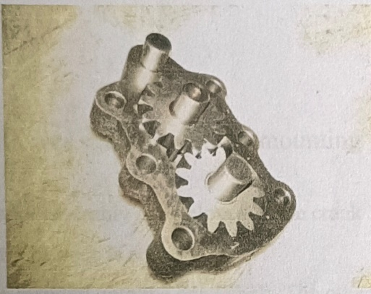Initially crank case is loaded onto line and Lubricant Oil Pump (LOP) gear sub assembly is mounted onto the crankcase.

*FIG.4.1*

1. Bearing mounting ring is mounted on the crankcase upon which the flywheel is mounted later.
2. During this stage sub assembly of computer balance, flywheel and crank shaft is done.
3. Then bracket mounting on the crank case is done and is moved in for next process on the assembly line of engine.

**4.1.2** **Cam follower sub assembly & mounting**

1. A governor assembly is employed to the crank shaft. LOP gear is mounted.

2. A counter balance is added.

3. A key is inserted onto the crankshaft. The other half of the key sits in the pinion gear.

4. The cam gear is in meshing with the pinion gear.

5. 3 cam gear followers are present. One for fuel, one for inlet valve, one for exhaust valve.

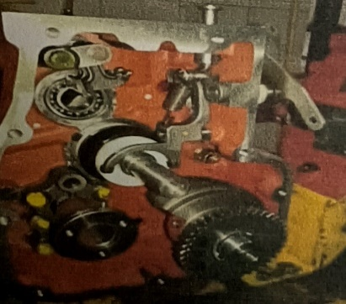6. 4 mounting roads are interested to hold the cylinder head assembly

*FIG.4.2*

**4.1.3** **Fly Wheel Bush Filament**

1. The engine is rolled in the opposite side to attach the flywheel.
2. Silicone gel (acts as a gum) is added on the outer ring and on the fly wheel.
3. The mounting flanges are bolted. Manual inspection of bolts is done and marked yellow.
4. Dowel pin is inserted on the crank shaft.
5. Flywheel is mounted taking the dowel pin as reference and the flywheel is locked using 6 allen nuts and later the dowel pin is removed.
6. Starter motor is made to mesh with the flywheel.
7. Oil filter brackets is inserted

**4.1.4 Piston & Oil Sump Mounting**

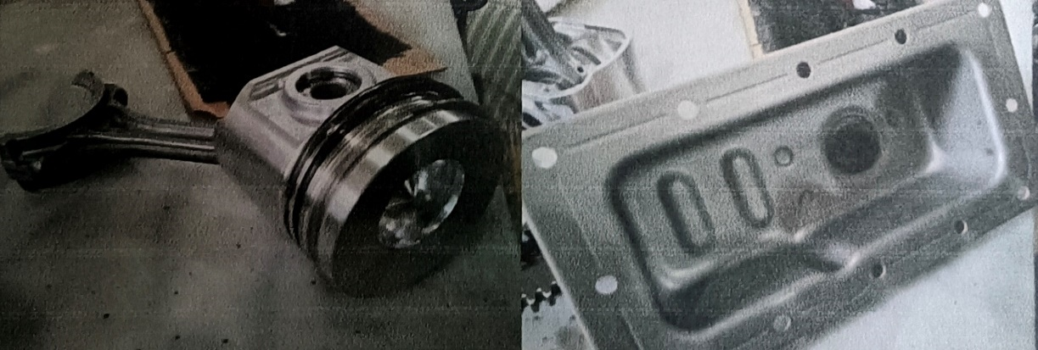

*FIG.4.3*

1. Rings on mounting roads are placed to raise the elevation of cylinder head and maintained samelevel with cylinder head and piston crown.
2. Cylinder block is inserted.
3. GOETZE piston & piston liners are used. It is the manufacturing company for pistons and piston liners.
4. IN PISTON Circlip is inserted. It is used to lock the gudgeon pin.
5. IN CONNECTING ROD Brass bearing is inserted on both the surfaces of bigger end of the rod. It wears first before the connecting rod surface.
6. Piston compresses of three rings.
7. 1" - Compression ring
8. 2nd --Scraper ring
9. 3rd - Oil ring

**Each ring is separated by 120 degrees clockwise starting from the upward arrow on the piston.**

1. Cylinder block is placed over the mounting rods and piston is fixed inside the cylinder block.
2. The big end of the connecting rod is tightened up from the bottom direction.
3. Strainer is attached from the bottom to filter the oil from foreign practicals. 4. Flange sealant is applied over oil sump and bolted beneath the engine.

**4.1.5 Timing gear train & back lash check.**

1. Cam shaft, driving gear and LOP gear are located in their respective positions.
2. The three gears are made to mesh with each other and after inspection dummy front cover is mounted.

**Inspection: Fuel timing & fuel cut off checking**

1. Fuel injection pump (FIP) is inserted near the cam shaft bearing.
2. Fuel is allowed to pass through the FIP and fuel cut-off is adjusted at 14
3. TDC using time setting gauge. For this adjustment, at the FIP SHIM's are used. One SHIM for I deviation.

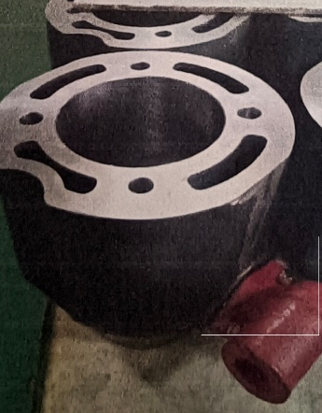**4.1.6 Cylinder head assembly**

*FIG.4.4*

1. Expansion plug is inserted at the bottom of the cylinder head. It serves as a blow off valve when there is some malfunction in the exhaust gas outflow.
2. Exhaust and inlet valve spools are inserted, the diameter of inlet valve is greater than that of exhaust valves rods,
3. Rocker arms are fixed in the cylinder head and springs are also placed on the inlet and exhaust valve rods.
4. In order to remove the extra air outside, Air Breather is added on top of the cylinder head.
5. Diesel spill pipe is also attached to allow excess oil to overflow.

**Push rod tube, Rocker arm cover, High pressure pipe are also added in the same stage.**

1. A smaller size dowel pins are added onto the mounting rods.
2. Gasket for cylinder head put on in between the case to the cylinder head. It is helpful in preventing the leakages of air during compression stoke.
3. High pressure pipe is inserted between fuel injector and fuel injector pump.
4. 4 Push rods connect cams to the rocker assembly for opening and closing of the valves.

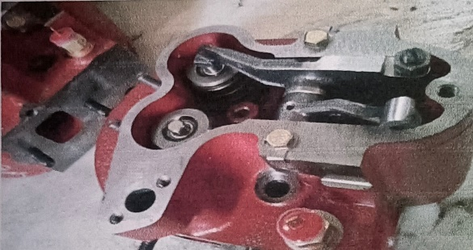

*FIG.4.5*

**4.1.7 Intake & Exhaust mounting fuel filter mounting**

1. Intake and exhaust manifolds are mounted.
2. Diesel filter is mounted on L-bracket on the flywheel body. It accommodates fuel pumps.
3. Banjo bolt is inserted into FIP. It has a cavity inside through which fuel is injected into FIP.
4. Water Pump is mounted in the opposite side of the flywheel. It supplies water to the water jacket surrounding the engine and other essential parts. It is connected to the main inlet of the water jacket through a hose.

**4.1.8 PTO mounting**.

1. PTO pulley is added. It is mounted on the crank shaft.
2. Oil filter is added opposite to the FIP. It purifies oil before entering the sump.
3. Low idle bolt is added to governor. It acts as a lever mechanism for throttling purpose.

**4.1.9 Alternator mounting**

1. Alternator/dynamo is attached on a mounting, top of the crank case.
2. Timing belt is added and runs over alternator, water pump and PTO pulley. Belt is tightened by displacing the alternator over a movable bracket and after required tension in the belt, the alternator is tightened.
3. Hydraulic pump mounting bracket holder is added.

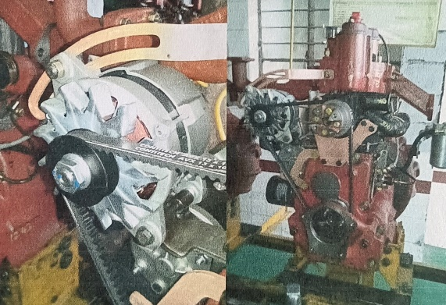

*FIG.4.6*

**4.2: Engine Testing**

1. 2.5 lit of engine oil is filled through the oil cap at the top.
2. Air cleaner is mounted above inlet manifold.
3. As per the following table, the engine testing is done.

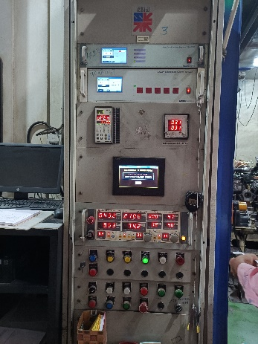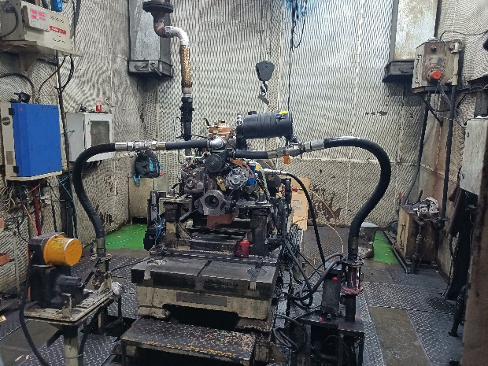

*FIG.4.7*

1. It is a check engine efficiency, power etc. It is used to check engine and get report of engine.
2. So, as the engine testing is done, the engines are kept aside in a row. After the engine cools down, they are taken out of the engine testing area and launch plate is mounted. **CHAPTER 5: TRANSMISSION SYSTEM ASSEMBLY**

|  |  |
| --- | --- |
| **Types** | Sliding Mess |
| **Speed Limit** | 6 foreword,3 reverse |
| **High Speed** | 25.62km per Hour |
| **Reverser High Speed** | 5.51km per Hour |
| **Breaks** | Dry disk break |
| **Clutch Types** | Single plate dry type |

*Table5.1*

Various Stages Of Transmission System Assembly Are As Follow:

**5.1: Spline shaft sub assembly mounting**

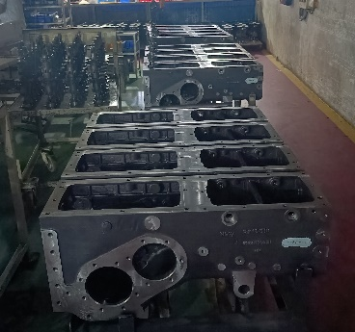1. Trans case is kept on the assemble line.

*Fig.5.1*

2. Spline shaft is inserted first and locked using Circlip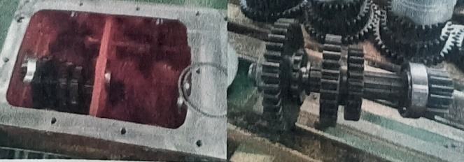

*Fig.5.2*

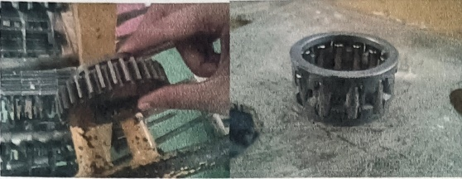 3. SHIM is inserted on the body upon which pinion shaft is mounted.

*Fig.: 5.3*

4. NRB and cluster gear are mounted on the spline shaft and locked with a lock plate.

**5.2 Reverse idler gear assembly**

1. Reverse idler gear is mounted.

**5.3 Rail and Fork Assembly**

1. Rail and fork are assembled on the transcase which helps in shifting the gears.

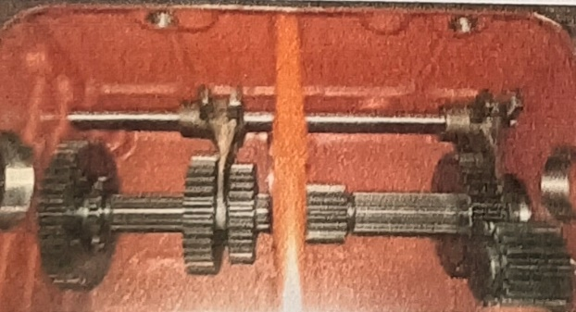2. Forks are placed in between gears.

*Fig.: 5.4*

**5.4 Lay shaft assembly**

1. Lay shaft is mounted in the next stage.

2. Gears on the lay shaft are remove, lay shaft is inserted from the front and the remove,

Gear are added again from top of the transcase

3. Loctite is applied on outside body to avoid oil leakage.

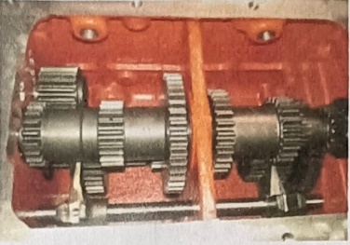4. From the sides ring, bull case are mounted.

*Fig.: 5.5*

5. Gear rods are inserted into position by connecting them with forks through an overhead

shaft.

6. The order of gear arrangement are first, second, third, high, low, reverse.

**5.5 BLACKLASH (Differential)**

1. When both bull pinion shaft are rotated in the opposite direction, there exists some play in between both the shaft.
2. This is backlash this error is rectified by adjusting the stud gear and the play is minimized.

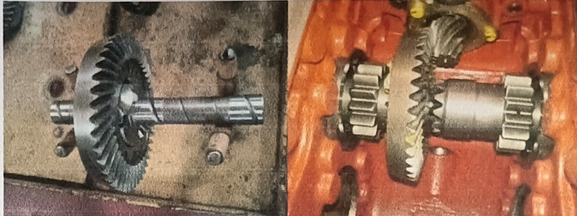

*Fig.: 5.6*

1. The back lash deflections accepted are different for different directions

Right hand gear -0.2μm to 1.3μm

Left hand gear -0.2μm to 1.3μm

Pinion gear -0.2μm

4. Oil seal added to the bull case at the outer side of the transcase near the bull case end.

5. Dye shaft is connected to the lay shaft.

6. Silicone gel applied on the face of clutch housing, bolted to transcase and is worn over the dye shaft

7. Gear box is covered with a plate and tightened with bolts.

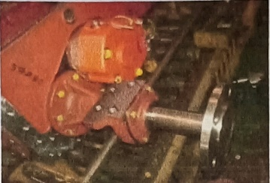**5.6 RAC sub assembly mounting**

*Fig: 5.7*

1. Sealant is applied to the body to avoid leakage.
2. Remove RAC locknut, lock plate, bull gear and their SHIM's from RAC assembly.
3. Insert bull gear, lock nut, and lock plate.
4. Place all the bolts and tighten them using appropriate torque.(100N)

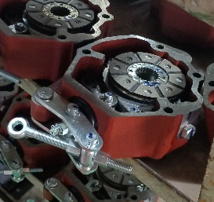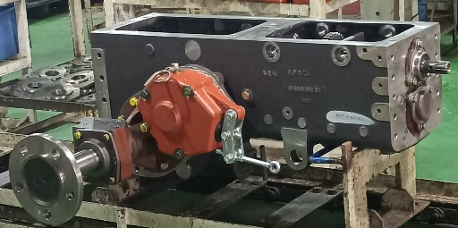**5.7 Break assembly mounting**

*Fig:5.8*

1. Insert brake liners on bull pinion shaft. Apply sealant on the housing of the brake mounting.
2. Attach the brake housing over the brake liner and bolt them up, tighten the bolts.
3. Install air pipe on the brake assembly using a banjo bolt and lock it with a brass

nut.

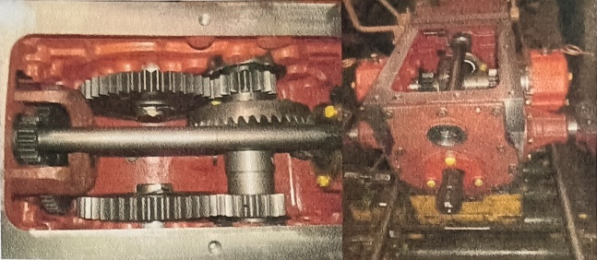**5.8: PTO shaft mounting**

*Fig:5.9*

1. PTO shaft is directly coupled with the lay shaft. It has a direct attachment from the gearbox without transferring the power to the spline power is directly transmitted through lay shaft.
2. It is bolted and then properly tightened.
3. A seal is positioned into outer side of the PTO shaft.
4. The PTO shaft is mounted, lock with nuts on the side opposite to PTO gear.

**5.9: Transmission leakage testing**

1. Air leakage test.
2. Lock the suction filter mounting hole with plug.
3. Connect the air pump to leakage testing plate.

**Specification of the leakage test**

1. Leakage testing pressure - 100mbar
2. Initial air filling time-30sec
3. Allowable leakage value - 50cc/min

**Oil testing**

1. Whole gear box fill with 16liters of servo 13T oil.
2. Motor connected and start.
3. Possible chances of leakage are noted, even during the application of brakes.

**CHAPTER 6: VTU-VARY TAKE UNIT**

**6.1: VTU Assembly**

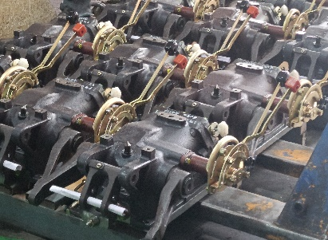 **6.1.1 VTU Body**

*Fig:6.1*

1. Rocker arm is mounted on rock shaft, rock shaft mounted on VTU body.
2. Cam PC is added. It is used to bring back the spool valve into position.
3. Rock shaft bush is added. Washer is added on one side and oil seal on both sides are added in order to prevent oil leakage.
4. Lift arm is inserted on both the side and locked with a circlip. V. Crank toppling is locked with draft sensing element.
5. PC roller, PC link, DC link are mounted on the quadrant shaft. These three are interconnected.
6. DC bush lock with DC outer.
7. DC outer is cabled with crank toppling.

**6.1.2 Control Valve**

It comprises of spool valve, pressure valve, relief valve.

1. When isolation valve is closed, piston entry of oil is not permitted. It goes to relief valve and then goes out. From this maximum pressure of relief valve is measured.
2. When spool valve is pressed inside, the oil flows into the piston continuously.
3. In order to avoid this DC cable which is attached with the PC roller, pulls back the spool valve and oil entry to the piston is stopped.

**6.1.3 VTU Testing and setting**

1. The level of lift arm is set to zero degrees with reference to the horizontal axis.
2. The maximum value of pressure is noted when the non-returning valve opens. It is also called as the relief valve pressure.
3. During testing maximum capable load and maximum allowable angular lift is set.

**CHAPTER 7: PAINT SHOP**

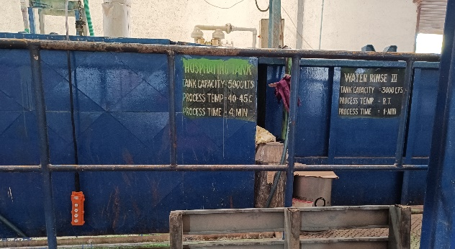**Hood and faders are go through 8 different tanks.**

*Fig:7.1*

**Tank:-1 Degreasing:**

Tank Capacity-3000Lts

Process Temperature-50-70`C

Process Time- 4-min

Fc436

**Tank:-2 Water Rinse-1:**

Tank Capacity-3000Lts

Process Time- 1-Mins

**Tank:-3 Water Rinse-2:**

Tank Capacity-3000Lts

Process Time- 1-Mins

**Tank:-4 Surface Activation:**

Tank Capacity- 3000Lts

Process Time- 1-Mins

PL-ZS

**Tank:-5 Phosphate**

Tank Capacity-5000Lts

ProcessTemperature-40-45`C

Process Time-4-Mins

PB-L 3020m

PB-L 3020RI

NT-4055

**Tank:-6 Water Rinse-1**

Tank Capacity- 3000Lts

Process Time-1-Mins

**Tank:-7 Water Rinse-2**

Tank Capacity-3000Lts

Process Time-1-Mins

**Oven-1 Water-Dry-Off-Oven**

Process Temperature-100-120`C

Process Time-10Mins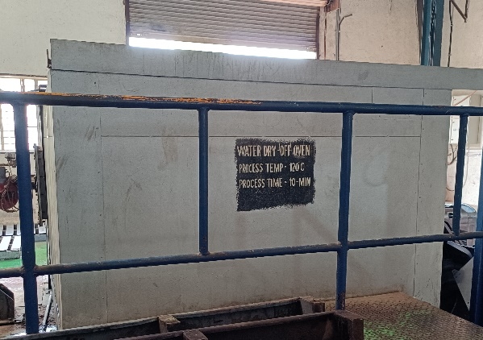

*Fig:7.2*

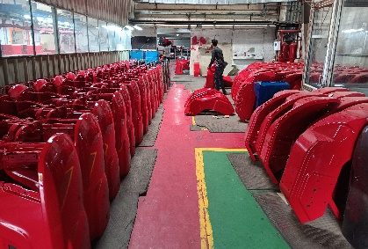**Apply Paint On Tractor Body Parts**:-

*Fig:7.3*

1. First is going to need to preped our tractor’s Hood and faders surface properly by removing rusty patches, Some of these areas might need to be replaced by new bits of sheet metal.
2. Hood and faders are going to have to sand every area of the tractor Hood and fader you are going to want to paint.
3. Paint the body with three coats, the first should be light and the second and third should be medium to heavy coats.
4. Allow drying for around 1-2 hours between coats. Do not go overboard with the coats as a thick coat tends to be scratched easier. It does take practice when applying the coats, but you will get there with practice.
5. Let the paint cure for two days and then mask off the body and paint the frame. Make sure that the paint is cured properly otherwise the tape will pull the paint off.

**CHAPTER 8: CONCLUSION**

1. Panchnath auto tractor have a very good market share in the vehicle segment specifically Yuvraj.
2. The company is offering good services, which is reflected on the satisfaction of the customer.
3. Majority of the customer are satisfied with the design of the Tractor. Panchnath auto are providing better facilities as compared to other brands.
4. As 67% of the respondents are satisfied that they are happy with the products, it satisfies that the customer satisfaction levels are very high. If the company were to identify the pitfalls in their product and undertake remedial measure, thus it will lead to more good word of mouth publicity.
5. Though majority of the customer are satisfied that the maintenance cost of Mahindra vehicles is less, around 20% are not satisfied which may be because of comparison with the newly launched competing brands coming with even lower maintenance cost.
6. As 80% of the respondents are happy with the space availability in Yuvraj vehicles, it can be conducted that the company has undertaken proper R&D in this aspect.
7. A 20% of the respondents who have answered negatively may be comparing with the vehicle in the same category launched very recently.